**CO1_Program 1**

IDE stands for Integrated Development Environment. It’s a coding tool which allows you to write, test, and debug your code in an easier way, as they typically offer code completion or code insight by highlighting, resource management, debugging tools,… And even though the IDE is a strictly defined concept, it’s starting to be redefined as other tools such as notebooks start gaining more and more features that traditionally belong to IDEs.

Comparison between IDLE and Thonny

Thonny is built for education and you can download the latest version from the Thonny website. The download options are at the top right. Thonny looks quite different to IDLE - it has different panels for the editor, the shell and the variables watcher plus (show view) lots of other options as well. It has a powerful debugger built in and other tools which let you manage packages and plugins.

The Idle editor comes built-in with Python and is the one that many tutorials use by default. It's a fine, basic, editor that also has a Python shell built in for interactive programming.When you start Idle up, you get the shell window. This allows you to execute python commands and see the results immediately without having to create a program. This can be useful for trying things out.

**CO1_Program 2**

s=int(input("enter strat year"))

e=int(input("enter end year"))

if(s<e):

print(" leap year are:",end=" ")

for i in range(s,e):

if i%4==0 and i%100!=0:

print(i,end=" ")

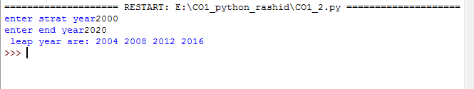

**CO1_Program 3**

list1=[-10,20,35,-67,70]

re=[num for num in list1 if num>=0]

print(re)

print("\n ................................. ")

n=int(input("enter limit:"))

squarelist=[i**2 for i in range(1,n+1)]

print("square of n numbers:",squarelist)

print("\n ................................. ")

word=str(input("enter the word"))

print("the original string is:"+word)

print(" the vowels are",end=" ")

for i in word:

if i in 'aeiouAEIOU':

print([i],end=" ")

print("\n ................................. ")

w=input("enter the word:")

print("ordinal value corresponding to each element is ")

for i in w:

print(i,end=":")

print(ord(i),end=" ")

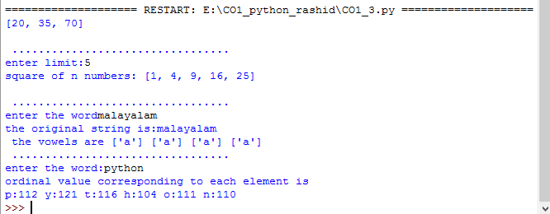

**CO1_Program 4**

str1=input("enter a string")

wordlist=str1.split()

count=[]

for w in wordlist:

count.append(wordlist.count(w))

print("count of the occurence:"+str(list(zip(wordlist,count))))

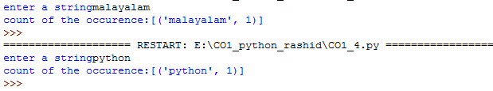

**CO1_Program 5**

n=[]

s=int(input(" enter a limit"))

print("enter {s} values")

for i in range(0,s):

n.append(int(input()))

print("\n the list after assinging: \n")

for i in range(0,len(n)):

if n[i]>=100:

print("over")

else:

print(n[i])

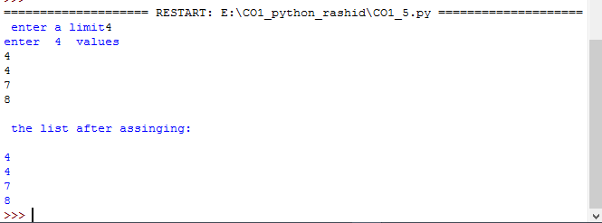

**CO1_Program 6**

a=["a","b","a"]

occ=a.count("a")

print("count of occurence of a:",occ)



**CO1_Program 7**

l=[1,3,5,7,9,11,34]

l1=[5,13,45,7,20,65,1]

s=int(0)

c=int(0)

if len(l)==len(l1):

print("list are of same length")

else:

print("list are of same length")

for i in range(0,len(l) and len(l1)):

s=s+l[i]

c=c+l1[i]

if(s==c):

print("equal sum")

else:

print("not equal sum")

print("elements that matched are:")

I=[]

for i in range(0,len(l)):

for j in range(0,len(l1)):

if l[i]==l1[j]:

I.append(l[i] and l1[j])

else:

continue

print(I)

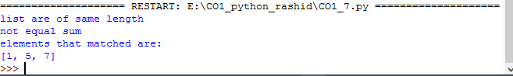

**CO1_Program 8**

str1="malayalam"

char=str1[0]

str1=str1.replace(char,'$')

str1=char+str1[1:]

print(str1)



**CO1_Program 9**

tr=input("enter a string:")

new_str=str[-1:]+str[1:-1]+str[:1]

print("New string: ",new_str)

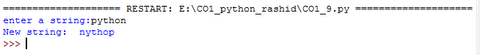

**CO1_Program 10**

pi=3.14

r=float(input("input the radius of the circle"))

result=3.14*r**2

print("the area of circle with radius is :",result)

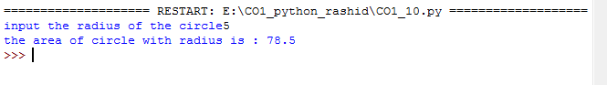

**CO1_Program 11**

x=int(input(" enter the 1st number"))

y=int(input(" enter the 2st number"))

z=int(input(" enter the 3st number"))

if (x>y) and (x>y):

lar=x

elif (y>z):

lar=y

else:

lar=z

print(lar)

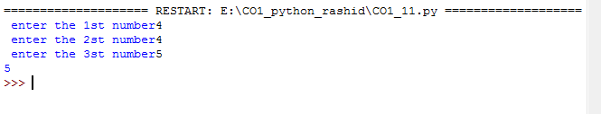

**CO1_Program 12**

file=input("enter the filename:")

f=file.split(".")

print("extension of file is:"+f[-1])

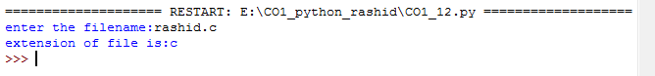

**CO1_Program 13**

a=[]

for i in range(3):

b=input("enter the color:")

a.append(b)

print(a)

print(a[0])

print(a[2])

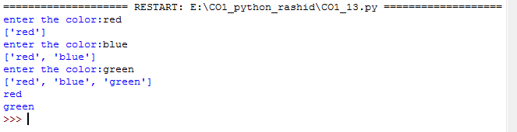

**CO1_Program 14**

n=int(input("enter a number:"))

x=int("%s"%n)

y=int("%s%s"%(n,n))

z=int("%s%s%s"%(n,n,n))

print("n+nn+nnn:",x+y+z)

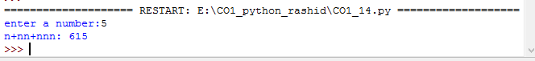

**CO1_Program 15**

color1=set(["white","pink","red","blue"])

color2=set(["red","green","pink"])

print(color1.difference(color2))



**CO1_Program 16**

a="python"

b="java"

p1=a[0]

p2=b[0]

c=b[0]+a[1:len(a)]+" "+a[0]+b[1:len(b)]

print(c)



**CO1_Program 17**

import operator

d={1:2,3:4,4:3,2:1,0:0}

print('original dictionary:',d)

sorted_d=sorted(d.items(),key=operator.itemgetter(1))

print('dictionary in ascending order by value',sorted_d)

sorted_d=dict(d.items(),key=operator.itemgetter(1),reverse=True)

print('dictionary in descending order by value:',sorted_d)

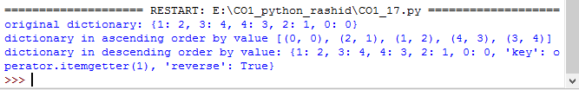

**CO1_Program 18**

d1={'a':100,'b':200}

d2={'x':300,'y':200}

print("Dictionary 1=:",d1)

print("Dictionary 2=:",d2)

d=d1.copy()

d.update(d2)

print(" merged Dictionary :",d)

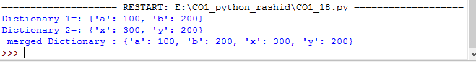

**CO1_Program 19**

x=int(input("enter the 1st number"))

y=int(input("enter the 2st number"))

i=1

while(i<=x and i<=y):

if(x%i==0 and y%i==0):

gcd=i

i=i+1

print("GCD:",gcd)

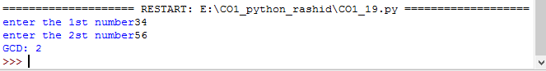

**CO1_Program 20**

num=[7,8,120,25,44,20,27]

print("Orginal list:",num)

num=[x for x in num if x%2!=0]

print("list after removing even number :",num)

